

CSM3023 WEB BASED APPLICATION DEVELOPMENT (K1)

**BACHELOR OF COMPUTER SCIENCE (MOBILE COMPUTING) WITH HONORS**

**SEMESTER 2 2023/2024**

LAB 6 – JSP: Saving and Retrieving Data from Database

**Prepared for:**

DR MOHAMAD NOR BIN HASSAN

**Prepared by:**

MUHAMMAD IZZUL WAFIY BIN IZAM (S65466)

Task 1 Coding :

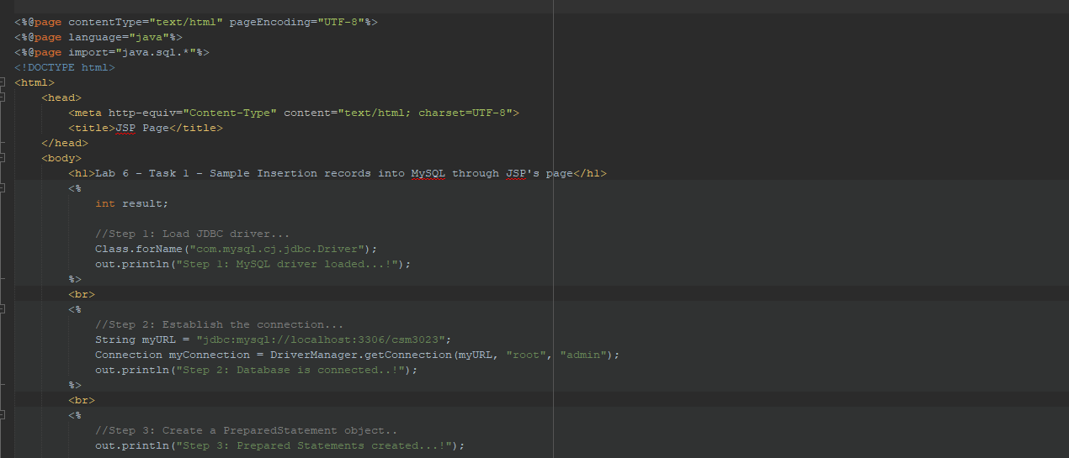

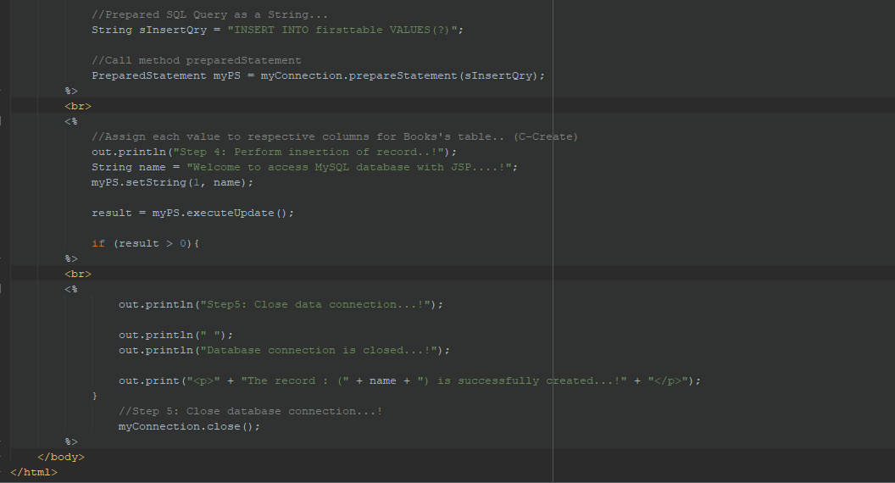

Output:

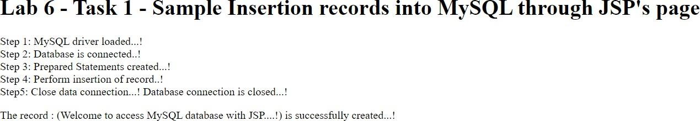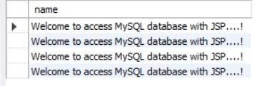

Task 2 : Coding :

insertAuthor.jsp

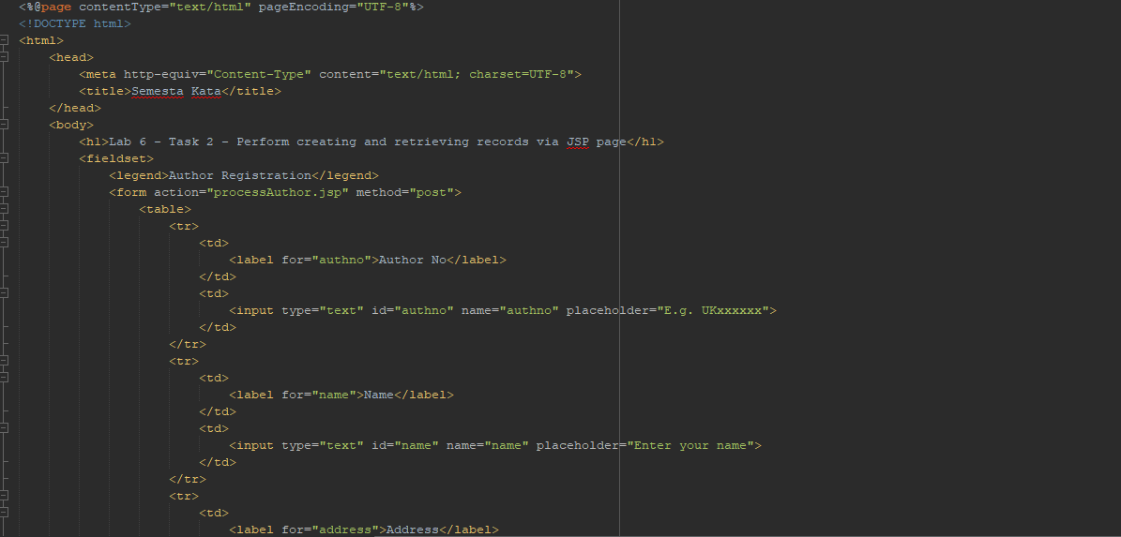

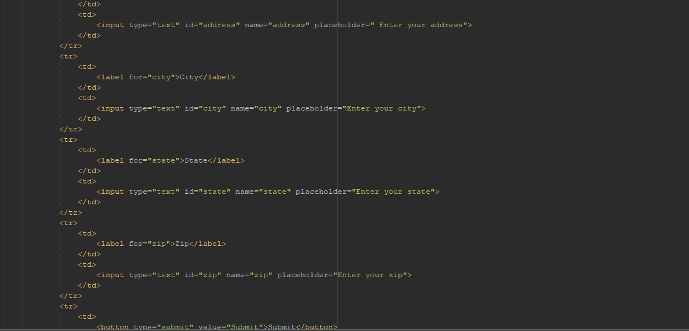

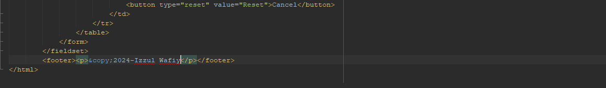

Author.java

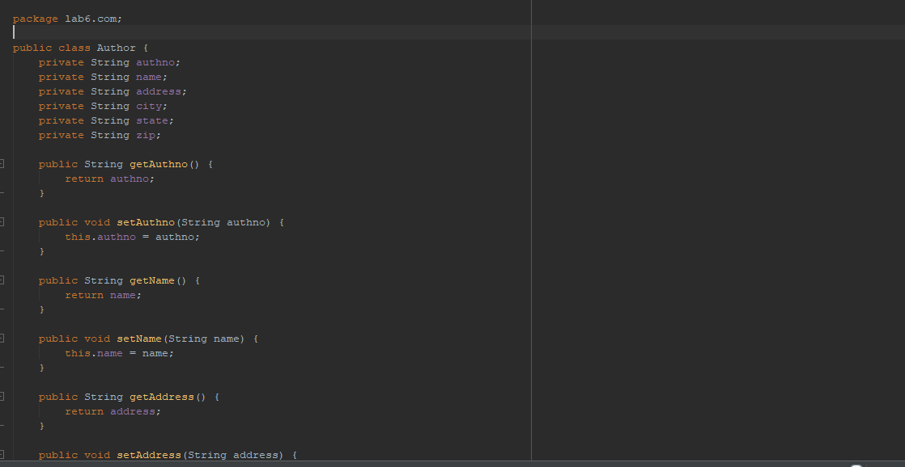

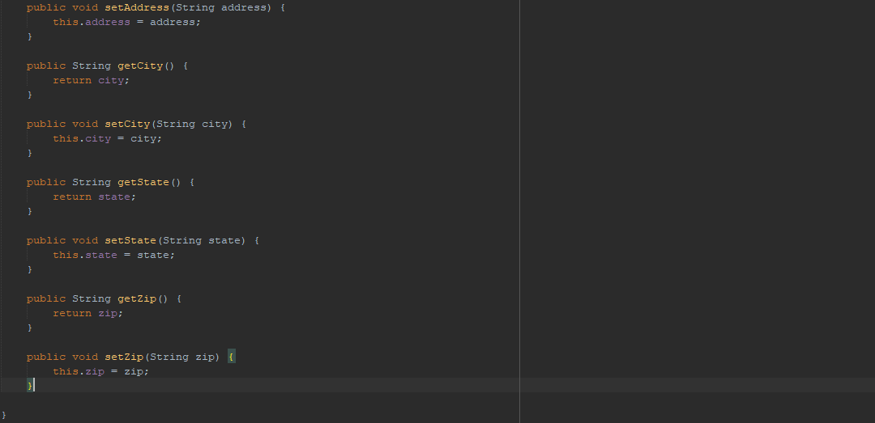

processAuthor.jsp

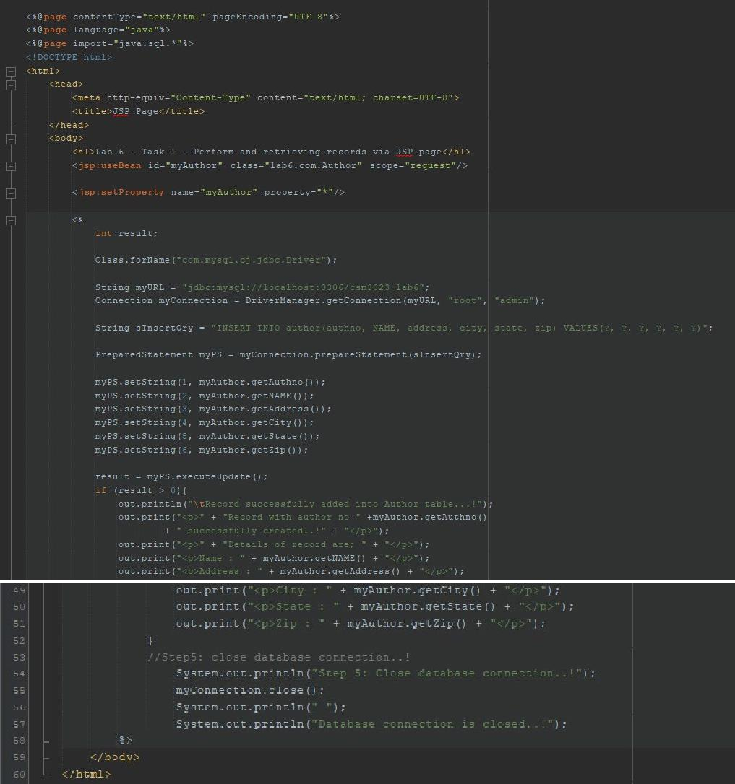

Output:

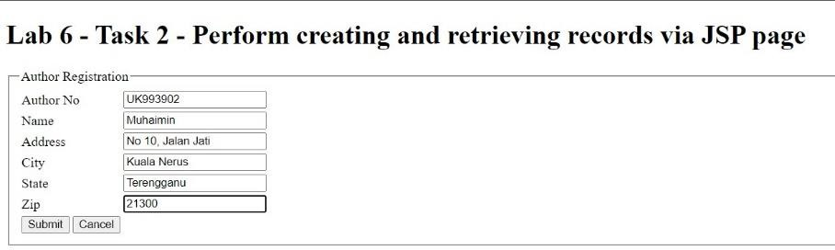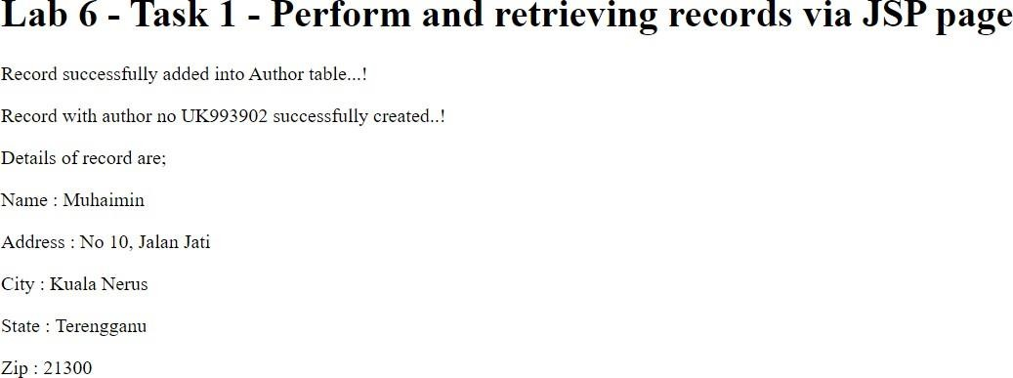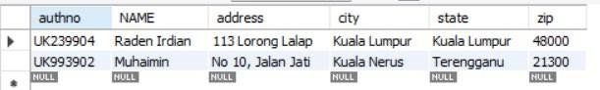

Reflection

1. What have you learnt from this exercise?

I have learn how to using JSP to insert records and retrieve them from MySQL database.

1. Define step by step before you successfully perform the transaction in a database.
2. Load JDBC driver.
3. Establish the connection.
4. Create a PreparedStatement object.
5. Execute the query.
6. Close database connection.

Task 3:

Coding:

insertStudent.jsp

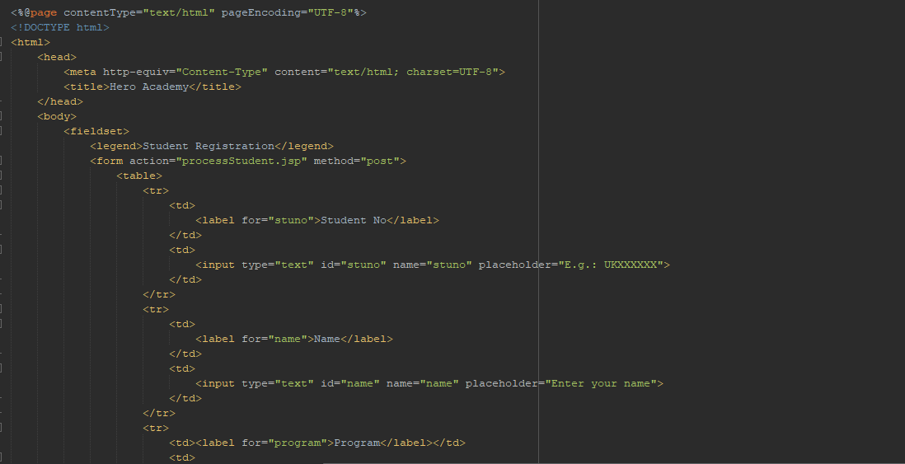

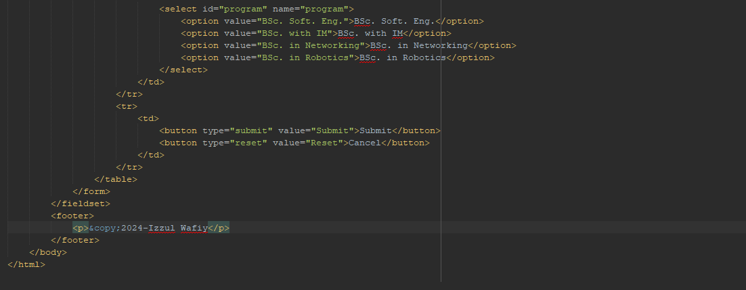

Student.java

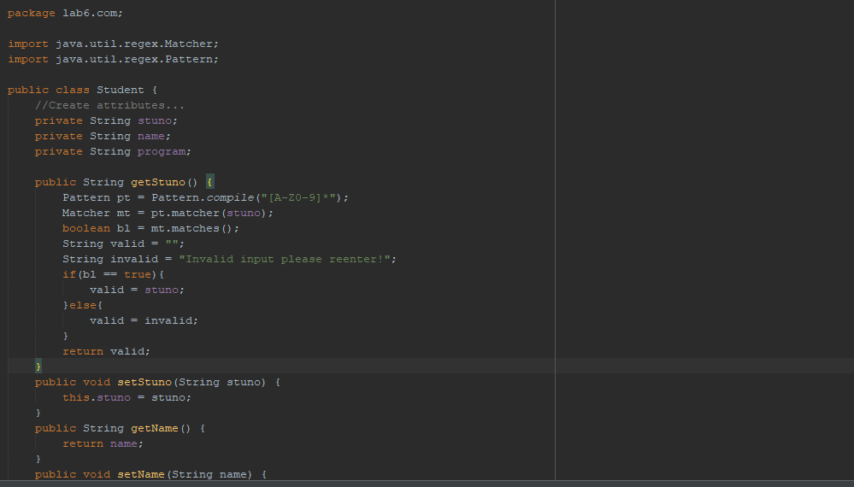

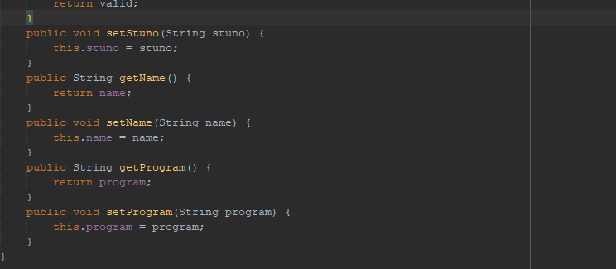

processStudent.jsp

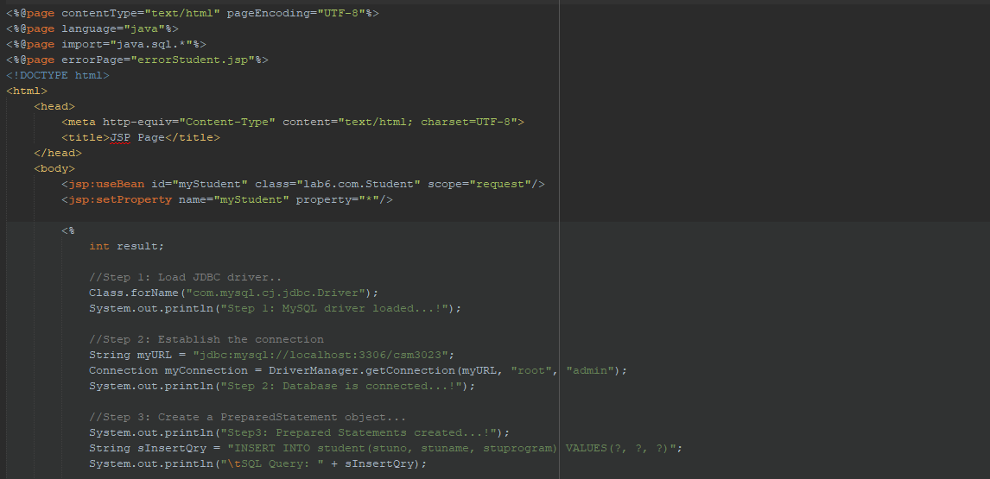

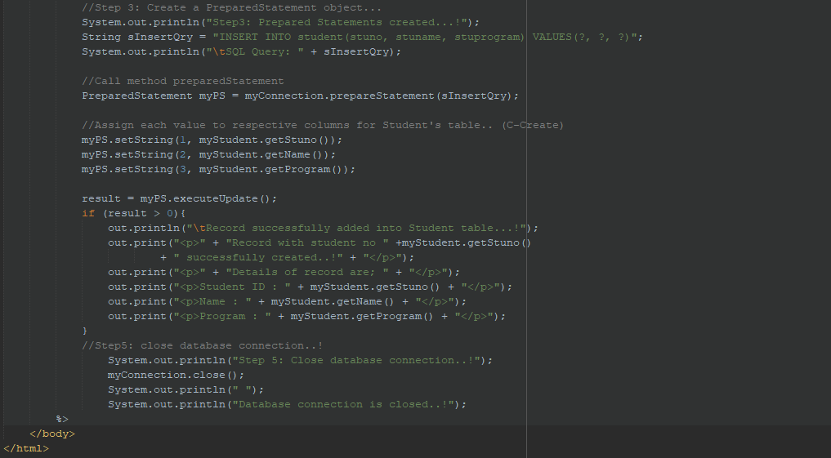

errorStudent.jsp

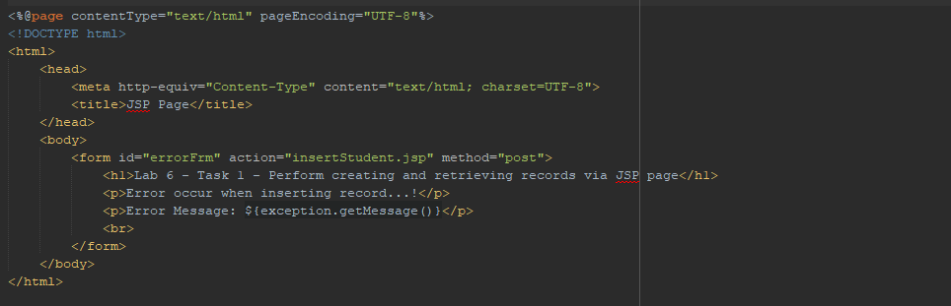

Output:

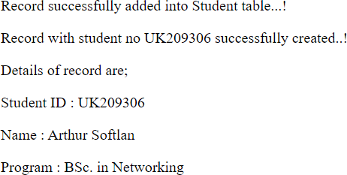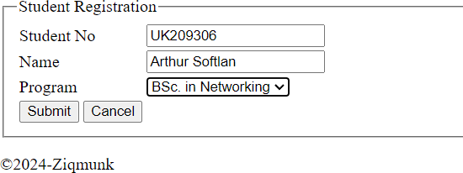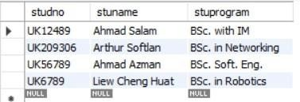

Reflection

1. What have you learnt from this exercise?

I have learnt how to use JSP Standard Action,scriplets and regular expression to insert records and retrieve them from MySQL database.

1. Define step by step before you successfully perform the transaction in a database.
2. Load JDBC driver.
3. Establish the connection.
4. Create a PreparedStatement object.
5. Execute the query.
6. Close database connection.

Task 4: Coding:

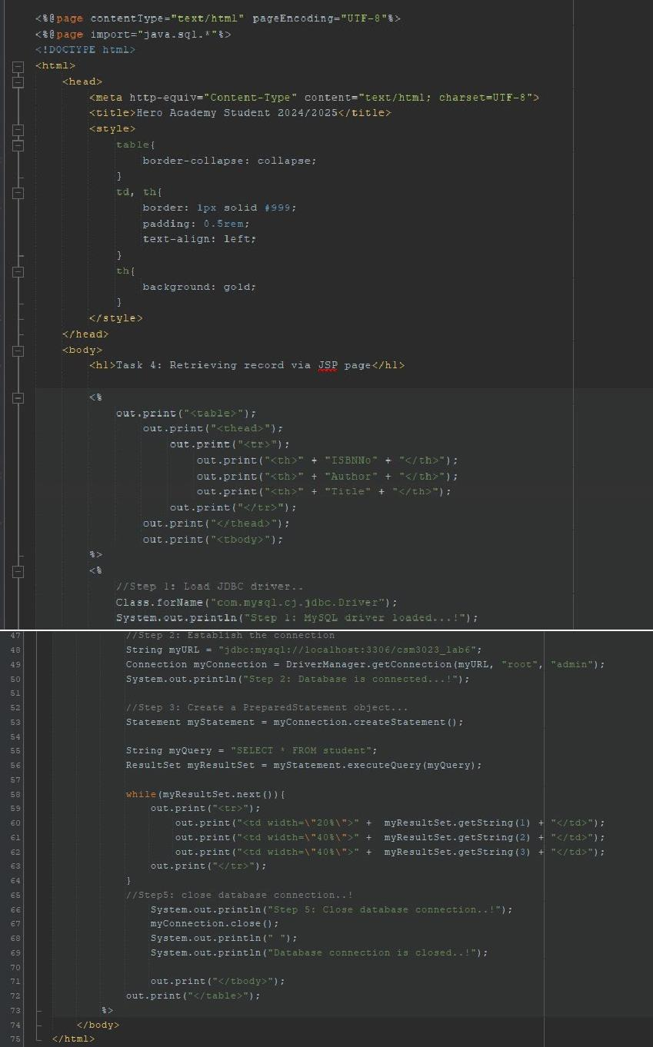

Output:

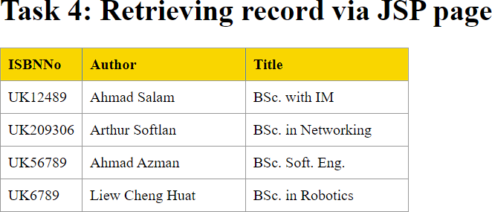

Reflection

1. What have you learnt from this exercise?

I have learned how to use Java Scriplet to query a list of records.

1. Explain the differences when using Statement() and PreparedStatement().

The Statement interface is used for executing static SQL statements while The PreparedStatement interface is precompiled and stored in an object.

Besides, Statement() cannot accept parameters at runtime while PreparedStatement() accepts input parameters at runtime (parameterized queries).

Statement() typically used for executing SQL queries that are run only once while PreparedStatement() Ideal for executing the same SQL query multiple times with different parameter values.

Task 5: Coding:

registerMarathon.jsp

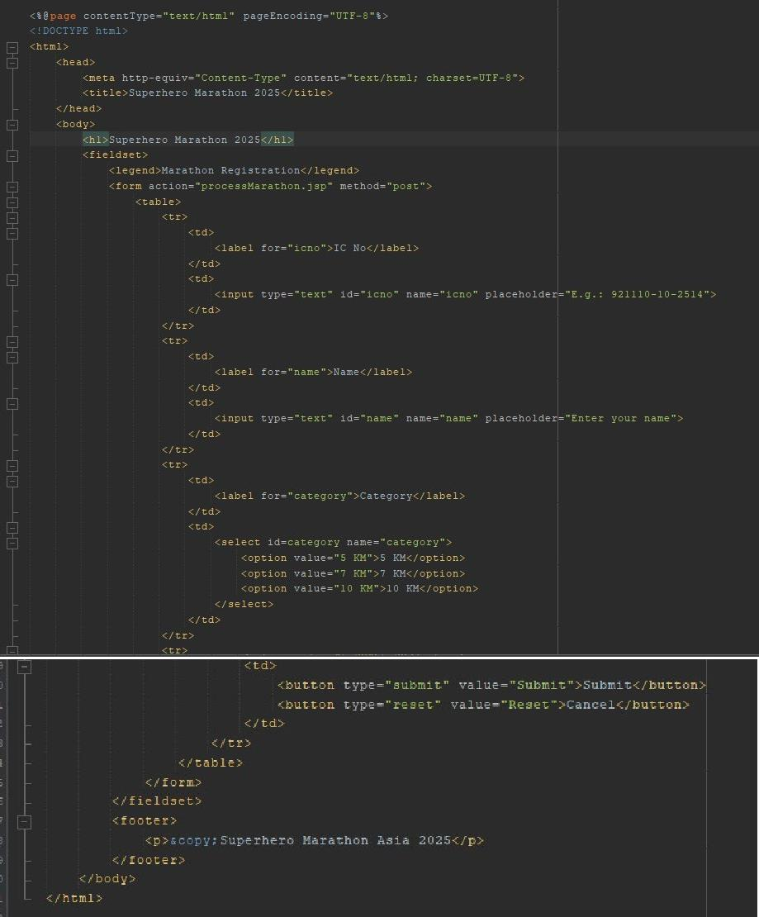

Marathon.java

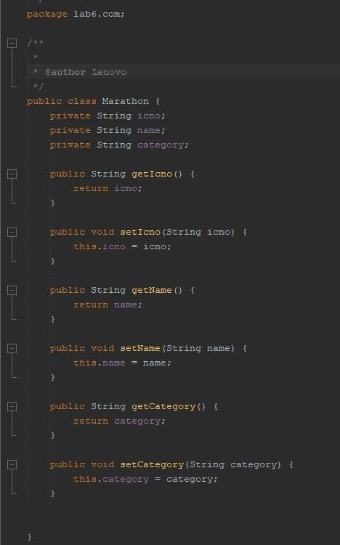

Database.java

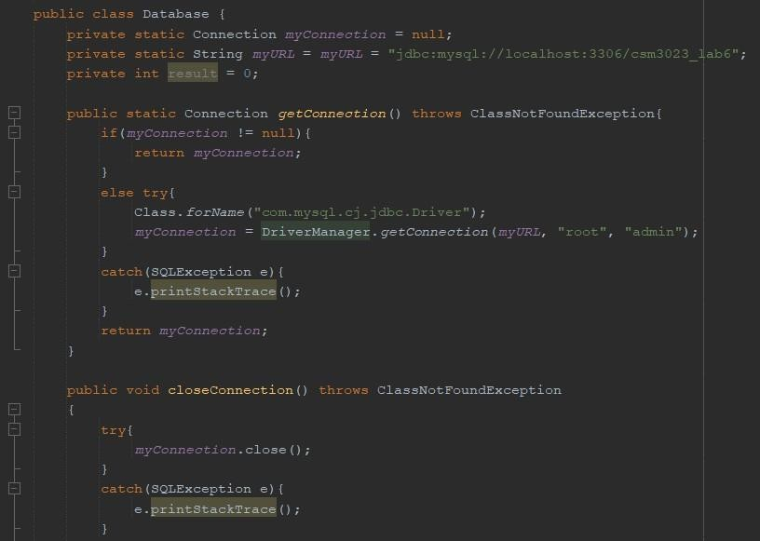

MarathonDAO.java

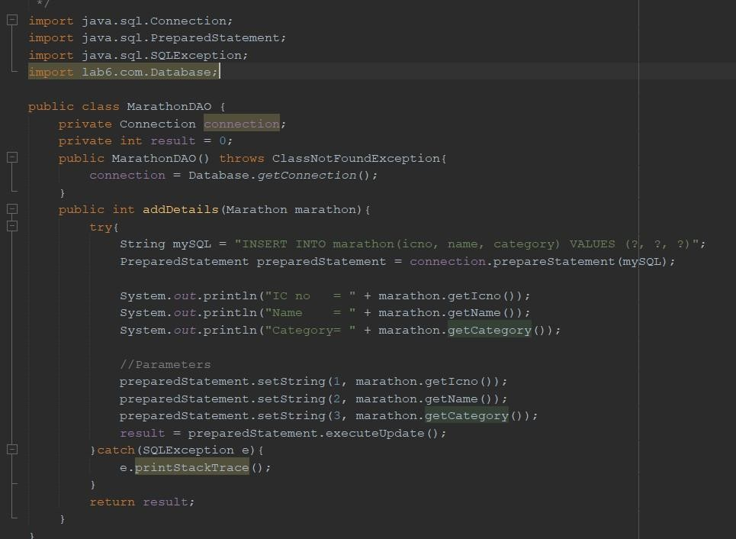

processMarathon.jsp

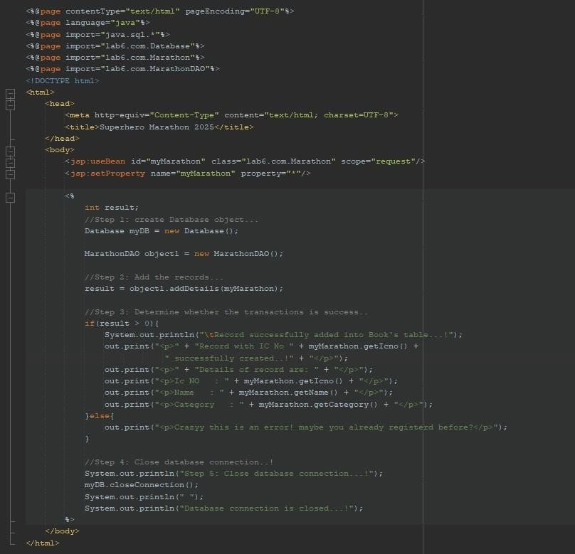

Output:

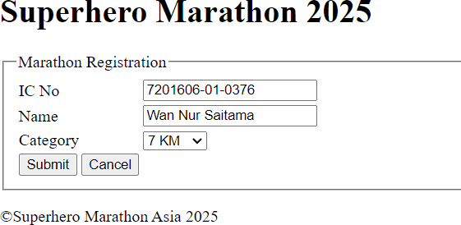

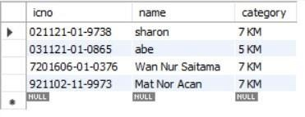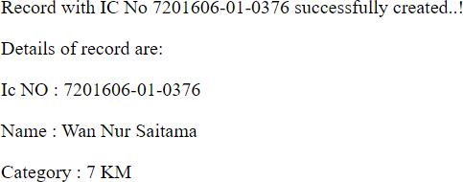

Reflection

1. What have you learnt from this exercise?

I have learned how to use JavaBeans to perform SQL transaction using PreparedStatement().

1. Describe the benefits of using JavaBeans

JavaBeans allow components to be reused across different parts of a program. JavaBeans are easy to configure and use.

They work across different platforms.

Exercise: Coding: insertUser.html

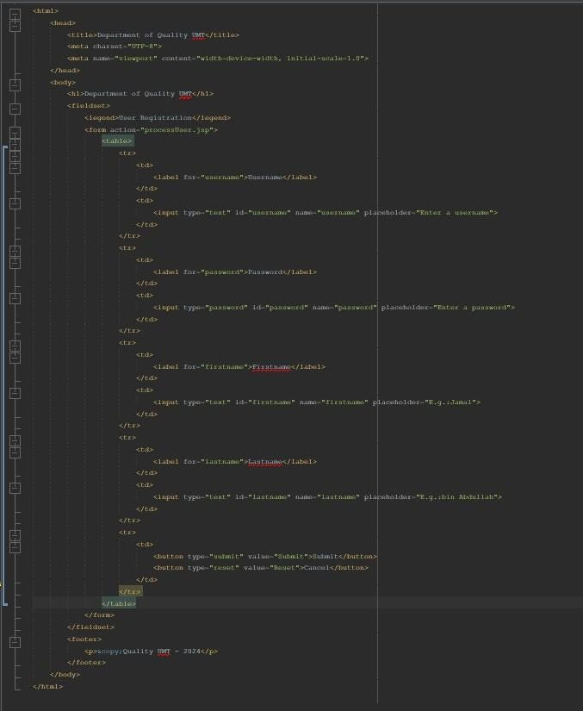

processUser.jsp

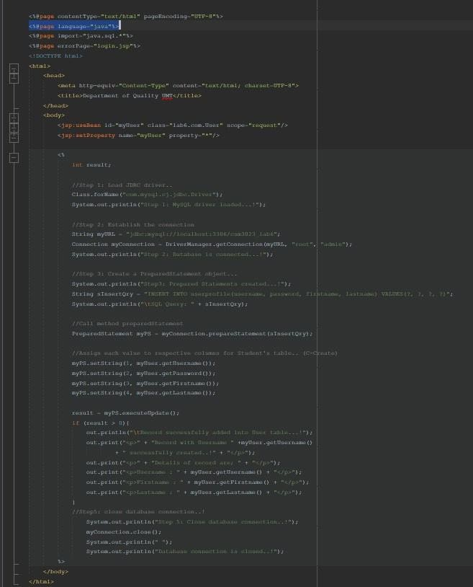

Login.jsp

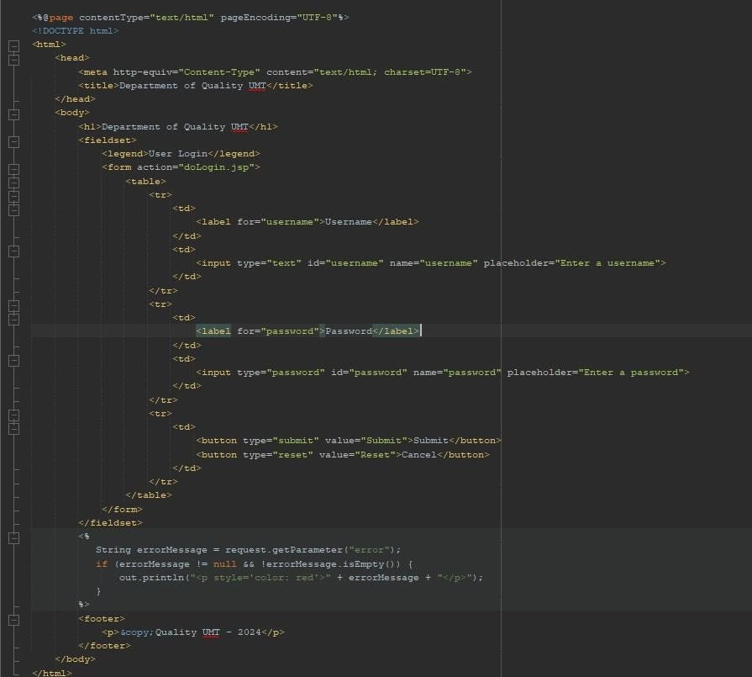

doLogin.jsp

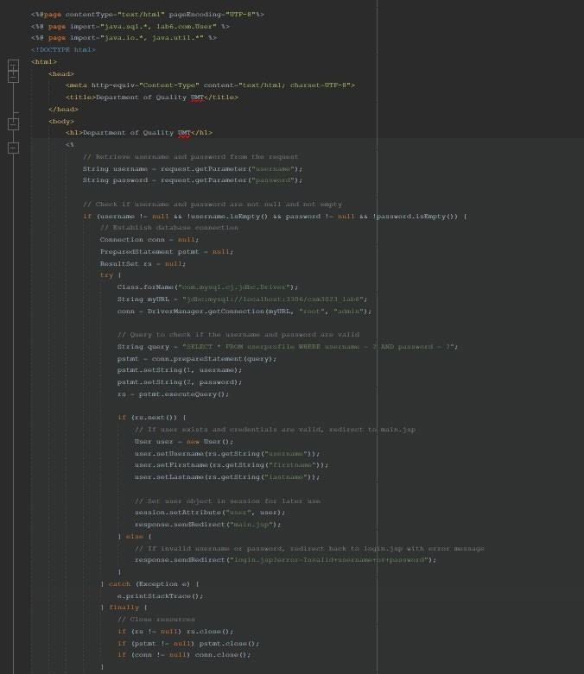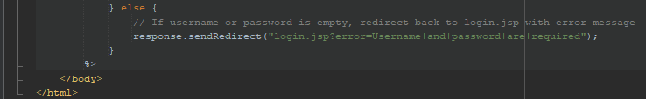

User.java

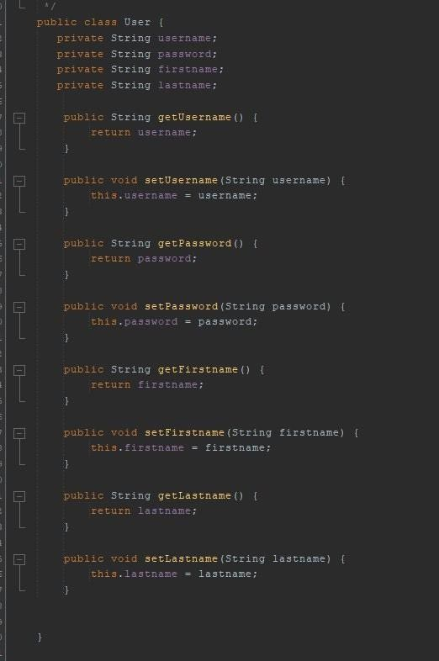

Output:

